Exercise 1: Configuring a Basic Spring Application
Create a new maven project with the name LibraryManagement
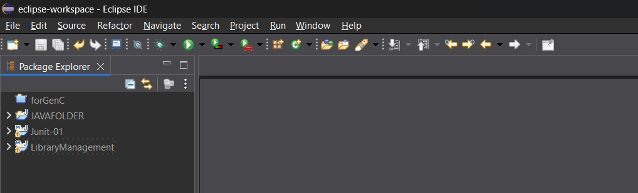
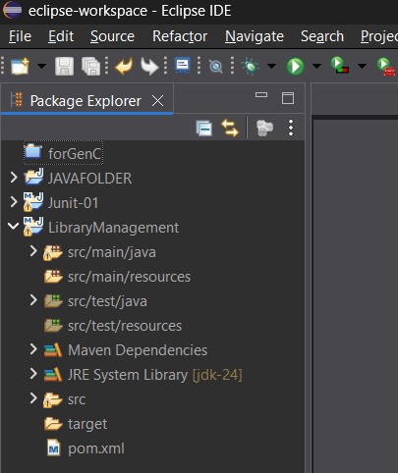
Add the dependencies of Spring Core and Spring Context in the pom.xml file
Which will download the required dependencies in the maven dependencies

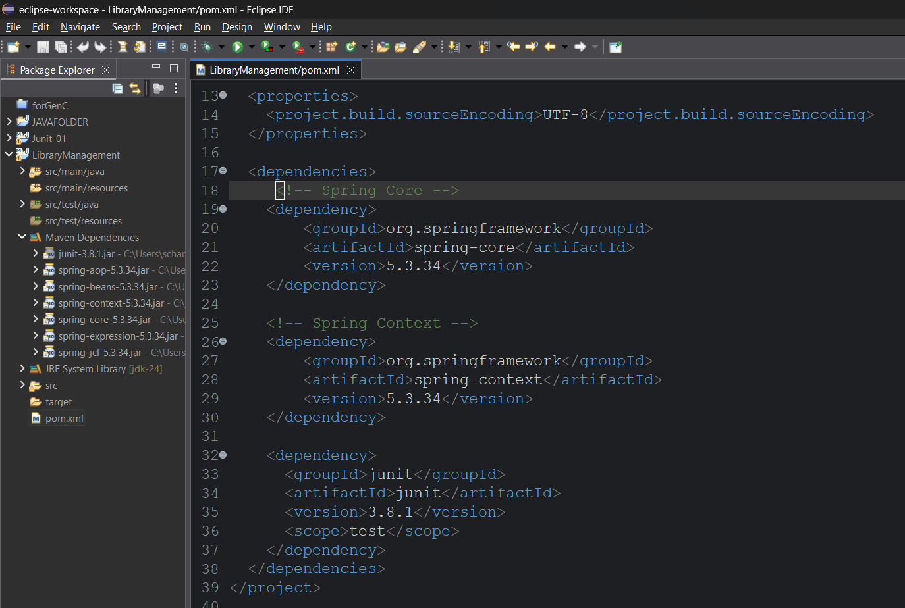
Now create two packages in the src/main/java
1) com.library.service
2) com.library. repository
Add BookService into the com.library.service package
Add BookRepository into the com.library. repository package
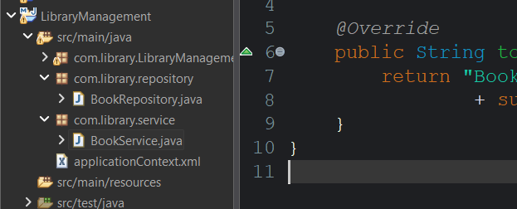
Override the toString() method or we can simple create the toString() method using eclipse by clicking generate toString() method in the source
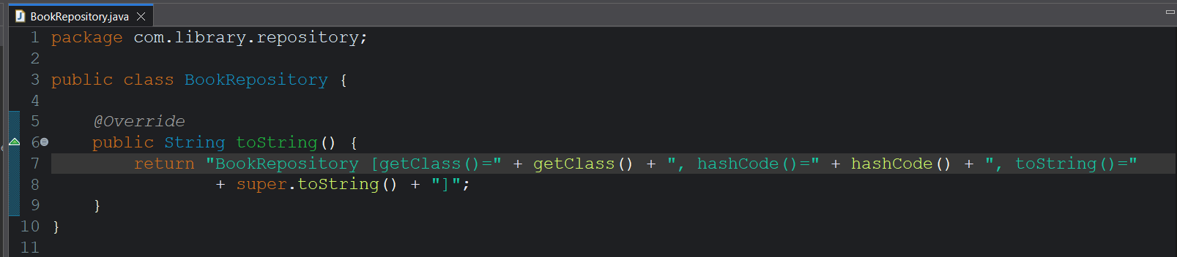
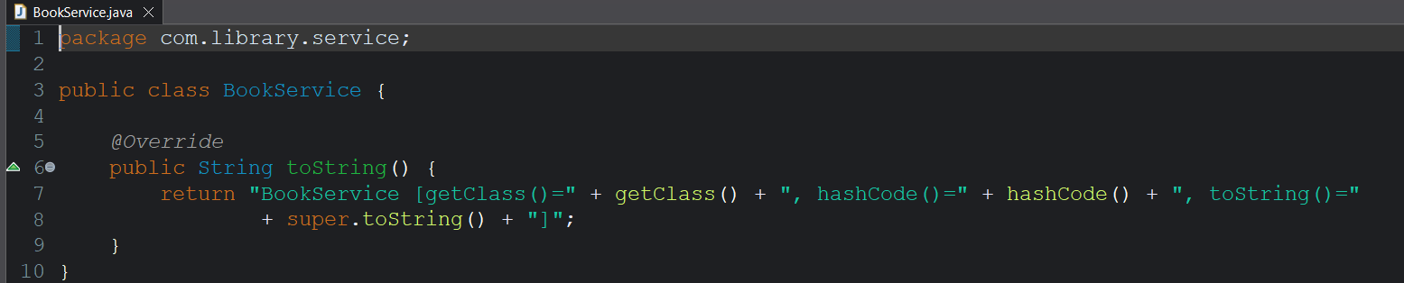
Now create an xml file to create beans for the created classes
Create a applicationContext.xml file in the src/java/main to set the Spring Bean Configuration

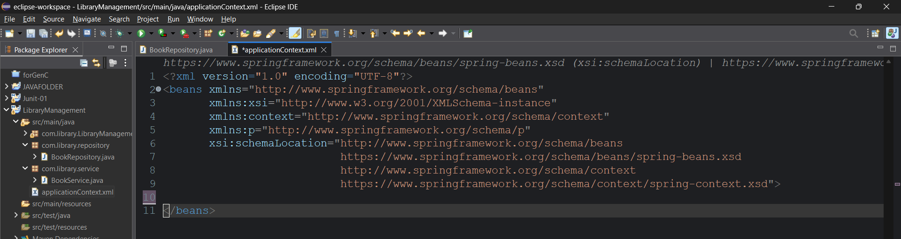
Now create the beans for the both the classes
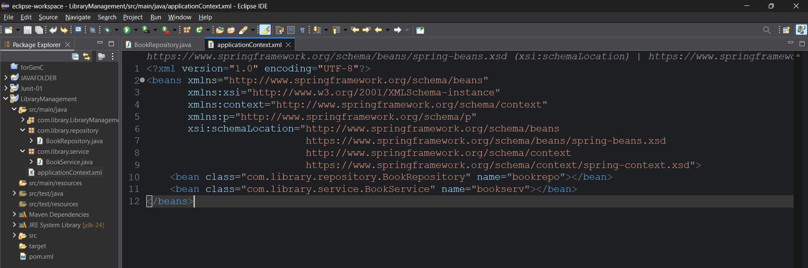
Now test them in the main class
While creating the maven project we have a App.java file in the src/main/java which contains main method to test out setup
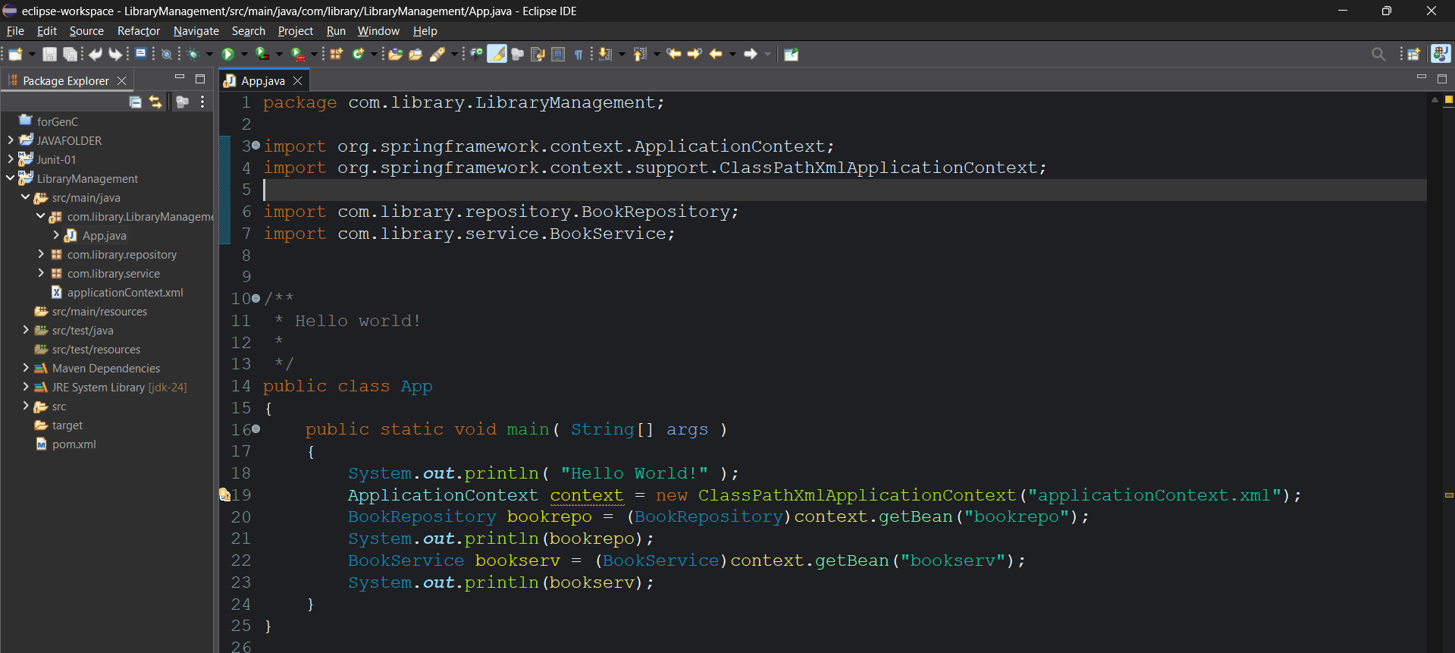
Run the java app.java file
Output:
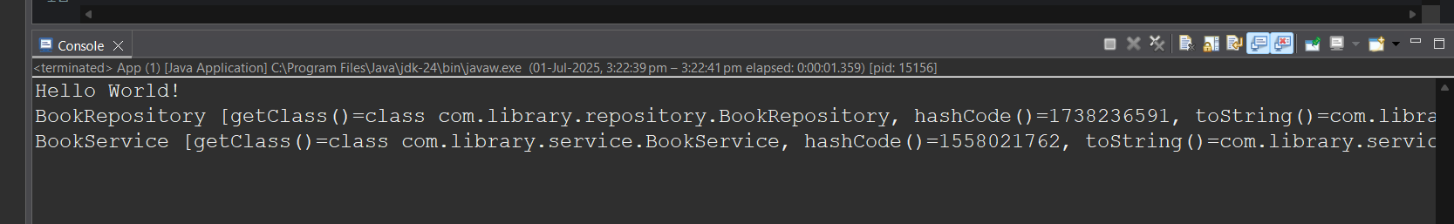
Since we are getting statements in the toString() method of both the classes it is working fine.

